Project Design Phase
Solution Architecture
Date | 12 October 2026
Team ID | 323103282097.aswija@gvpcew.ac.in
Project Name | ServiceNow Employee Raise Issue Portal
Maximum Marks | 4 Marks

Solution Architecture:
The architecture shows how an employee accesses the ServiceNow Employee Center portal, opens the issue form through the custom Raise Ticket widget, submits issue details, and creates a record in the custom issue table.
● Provide employees with a clear portal entry point to raise an issue.
● Use the custom widget “link_redirect” to navigate to the active “Raise Employee Issue” Record Producer.
● Capture requester name, category, subcategory, short description and issue state.
● Store submitted issues in the “Employee raises issues” table for review in ServiceNow.

Solution Architecture Diagram:
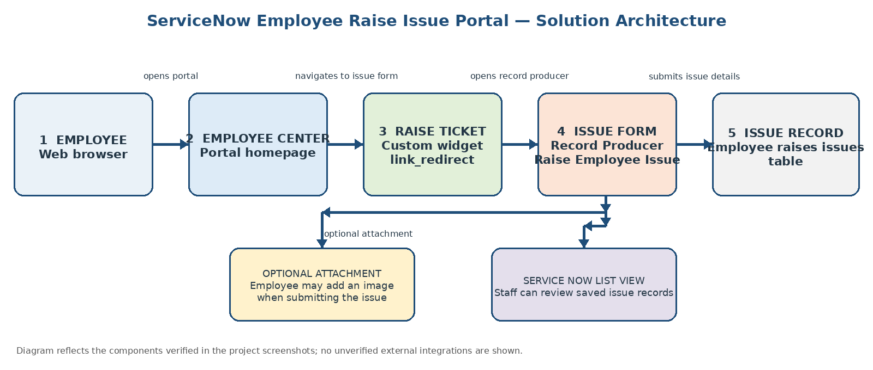
Figure 1: Architecture and data flow of the ServiceNow Employee Raise Issue Portal

Verified components: Employee Center portal, custom widget “link_redirect”, active Record Producer “Raise Employee Issue”, and custom table “Employee raises issues”. Specific access-control rules, automatic assignment, notifications, and external integrations are not claimed.

